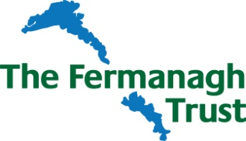

Slieve Rushen Wind Farm Fund Awards 2024/2025

Application Form

Applicant Details
Name of
Organisation/Group
Brief Description of Organisation
Charity Registration No (If applicable)
 | Name | Address | Telephone & Email

Chairperson

Secretary

Contact Person for this Application

Project/Activity Details

Title

Location
(attach map if appropriate)

Summary
(please attach further details if necessary)

Who will benefit from the results of this project/activity?

Overall Cost of Project/Activity

Amount of Funding sought from
Slieve Rushen Wind Farm Fund

Estimated Start Date (no retrospective applications can be accepted) |  | Estimated Completion Date
Amount of funding from other sources (please detail sources)

Breakdown of main costs of project/activity

Will the project/activity require ongoing funding afterwards? | Yes / No | If Yes, what are the sources of this funding?
Further/Supporting Information (ie, how will the project benefit the local community, how many people will directly/indirectly benefit from this funding, undertaking that the funding will be spent by 31st March 2025, project is located within 12km of the Windfarm).

Supporting documents required:
A copy of your organisation’s constitution
Written confirmation of charitable status if you are a registered charity
A copy of your organisation’s latest accounts
Most recent bank statement from all accounts

I/we the undersigned have read and agree to be bound by the enclosed Terms and Conditions of the Awards.

Signature…………………………………………………………….……………………………………….Date……………………………….…………….

Title………………………………………………………………………………………………………………………………………………………………...

Return completed form by 12noon Friday 7th June 2024, together with any supporting documents to –

The Director, The Fermanagh Trust, Fermanagh House, Enniskillen, BT74 7HR.
Tel: 028 66320210 or email: hazel@fermanaghtrust.org

To sign up the Fermanagh Trust email newsletter tick here

