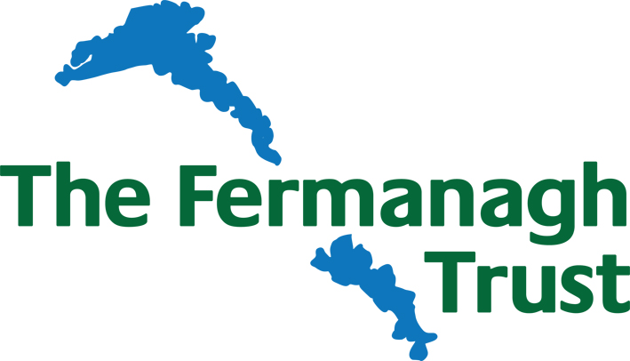

The Fermanagh Trust
Job Description

JOB TITLE: Executive Secretary (permanent post)

HOURS: 20 hours per week
9.30 – 1.30pm Monday – Friday. Will include evening work approximately 6 times p.a.

RENUMERATION: £21,255 - £23,400 per annum pro-rata

ACCOUNTABLE TO: Director

Objective of the Job:

To provide Secretarial support services to the Trusts Director and Trustees including grants administration

Duties:

- Supporting the Director in relation to administrative detail and coordinating work flow.
- Be responsible for checking deadlines and putting preliminary work in play. Processing replies on own initiative or from dictation or notes.
- Devising and maintaining office systems, in particular overseeing the grants administration process, data management and filing system
- Taking telephone calls, handling them as appropriate.
- Managing emails and devise a manageable filing system for emails.
- Typing correspondence
- Creating business presentations as required
- Managing the Director’s diary and time efficiently, including the arrangement of appointments, meetings and functions
- Writing minutes of meetings and ensuring that action points are dealt with.
- Compiling, photocopying and circulating board papers
- Diary management for board and committee meetings
- Liaising with trustees, staff colleagues and others, organising meetings, etc
- Ensuring an efficient flow of communications and information and being aware of current issues.
- Assuring discreet handling of all business.
- Accurate production of documents, including e-mails, general correspondence, memos and papers/presentations as required by the Director
- Managing internal events/activities
- Act as a key point of contact
- To maintain confidentiality in all dealings with trustees, staff and all customers
- Contribute to the smooth running of The Fermanagh Trust and the Trusts projects

OTHER

- To undertake any other duties and responsibilities which will assist in the achievement of The Fermanagh Trusts objectives

- To demonstrate flexibility in the execution of duties as part of a small team

- To conform at all times to the Trust ethics and values
- On occasions work will involve some evening hours

